2016-17 WWMS 6th Grade
T-Shirt Order

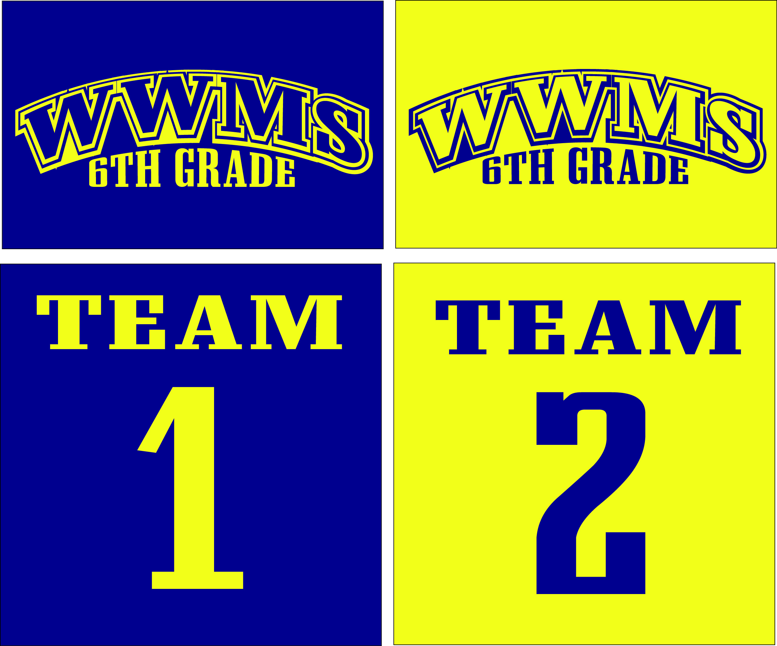
*Orders due by Friday, September 23, 2016*

Please Circle Your Size (adult sizes):
S M L XL XXL

Student Name: ______________________
Return to your Social Studies Teacher.
Circle the hour you are in Social Studies: 4th 5th 6th 7th

Cost: $10 cash or check #_______
(Please make checks payable to WWMS)

Thank you!

